Install MongoDB and myServer: Follow Angela Yu Video 327 or

* <https://medium.com/@LondonAppBrewery/how-to-download-install-mongodb-on-windows-4ee4b3493514>

Vim Insert mode:- for typing in vim just touch i

Every time you install a new database, check out the CRUD operations for that database

-MongoDB: <https://www.mongodb.com/docs/manual/crud/>

Starting the database connection and Executing database commands

- type mongod on the hyperterminal

- then open a new hyper tab and type mongo

-then you can interact with your database on the tab where you wrote mongo

help

-shows you all the database commands you can carry out

show dbs

-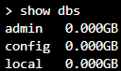

use shopDb

-creates a database called shopDb

-we can see it through show dbs only when the database has data stored inside it

db

- tells you which database you are currently working within

- 

Adding an element/elements to your database

-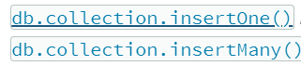

* collection means like a table name
* if that collection name doesn't currently exist then by writing this line and by executing it, it will actually create that collection.
* 
  + Adding to the products collection of shopDb

show collections

* It will show you all the collections that currently exist in the database
* 

Reading from database

* 
  + Reads all the data in the database
    - 

-

-

-display only prices greater than 1

-

-display fields of id 1 and display only their name and id fiel

-

-display only the name field

Adding columns

-

-adds the column stock to the row with id 1

Deleting a record

-

Integrating MongoDB with Node.js, two methods:-

-Native MongoDB Driver(jumped)

-requires you to write a lot of code

-Go to MongoDB drivers and choose node.js

-then choose Fundamentals>Connection> Connection Guide

Or

https://www.mongodb.com/docs/drivers/node/current/fundamentals/connection/connect/#std-label-node-connect-to-mongodb

-Mongoose

Connecting using Native Mongo dB driver

1st Create a new directory

2nd Create an app.js file (touch app.js)

3rd Type npm init -y

-the y says yes to everything

4th Type npm install [mongodb@4.8](mailto:mongodb@4.8)

5th For connecting your database to your server. Copy the boilerplate code from=

<https://www.mongodb.com/docs/drivers/node/current/fundamentals/connection/connect/#std-label-node-connect-to-mongodb>

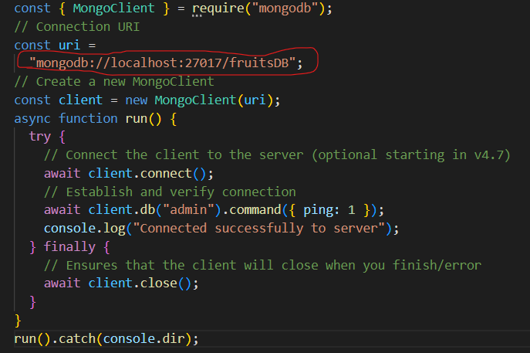

-modify the uri to your own URI(Not sure completely though how it works)

- our 5th step is totally unnecessary. It is optional in version 4.7 of MongoDB

6th type mongod in another tab

7th get back and type node app.js in Hyperterminal

-you will see a successfully connected message

8th connecting a database and inserting elements to your database. Add the below code in app.js instead of the code in 5th step

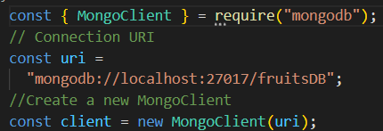

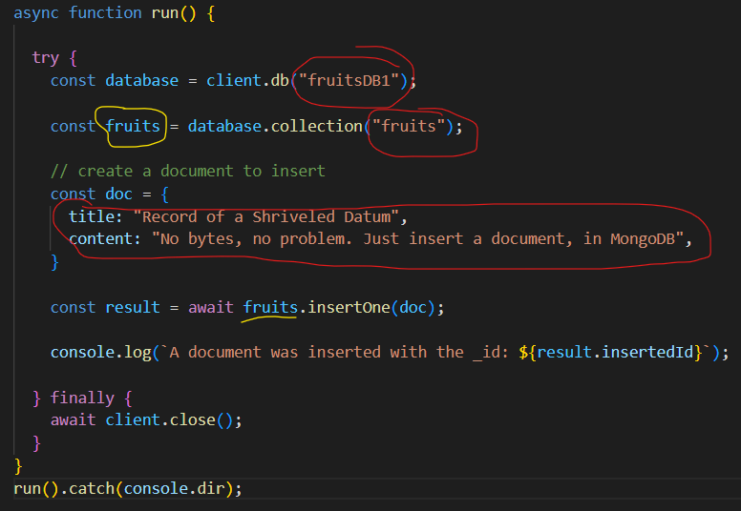

-modify the ones colored in red. The yellow colored ones are optional,

-fruitsDB1:- is the name of your database

-fruits:- is the name of your collection(table)

-doc:- is what you want to insert

- <https://www.mongodb.com/docs/drivers/node/current/usage-examples/insertOne/>

-the code is from the above link

9th If you want to insert multiple documents. Go to:

* + - <https://www.mongodb.com/docs/drivers/node/current/usage-examples/insertMany/>
      * Modify the relevant parts

-See below to check the parts we modified

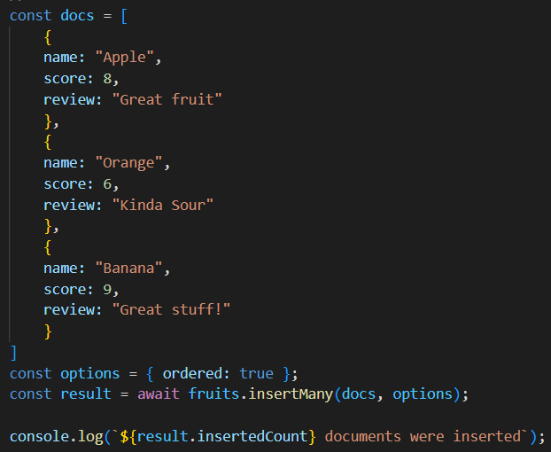

* An image of the parts modified for 9th step compared to 8th step

<https://www.mongodb.com/docs/drivers/node/current/usage-examples/find/>

* finding your documents in your database
* You can replace app.js with the code below.

